

FAKULTÄT FÜR INFORMATIK

DER TECHNISCHEN UNIVERSITÄT MÜNCHEN

Bachelorarbeit in Wirtschaftsinformatik

Serious Game für Management von IT-Projekten

Serious Game for Management of IT-Projects

Bearbeiter: Ixhen Hasani

Aufgabensteller: Prof. Gudrun Klinker, Ph.D.

Betreuer: Christian Eichhorn, M.Sc.

Adnane Jadid, Dipl.-Inf. Univ.

Abgabedatum: 15.Mai 2019

(Seite 1)**

* *Wiederholung der Angaben vom Deckblatt.*
* *Zusätzlich:*
  + *Titel der Arbeit sowohl auf Deutsch als auch auf Englisch.*
  + Aufgabensteller/in: *bzw.* Supervisor: *Titel, Vor- und Nachname des/der Aufgabenstellers/in.*
  + Betreuer/in/nen: *bzw.* Advisor/s: *Titel, Vor- und Nachname des/der Betreuer/in/nen.*
  + Abgabedatum: *bzw.* Submission date: *Abgabedatum (darf nicht handschriftlich sein)*
    - *entweder das tatsächliche Abgabedatum*
    - *oder Deadline der Abgabe (der 15. des Monats).*
* *Bitte beachten:   
  Keine Angabe von Matrikelnummer oder anderen persönlichen Daten wie Geburtsdatum.   
  Kein Firmenname oder Firmenlogo.*\*\*

(Seite 2)***

* *Folgende Erklärung:*  
  Ich versichere, dass ich diese Diplomarbeit | Masterarbeit | Bachelorarbeit selbstständig verfasst und nur die angegebenen Quellen und Hilfsmittel verwendet habe.  
  *bzw.*  
  I confirm that this diploma | bachelor's | master's thesis is my own work and I have documented all sources and material used.
* *Mit Datum der Unterschrift (darf auch handschriftlich sein) und Unterschrift im Original.*

Seite 3(Gliederung)

Introduction

*~~(Talk about the importance of IT/IT projects management and their evolution)~~*

*1.1 The importance of IT/ IT projects management and their evolution.*

With the ever growing evolution of technological components of our world, the importance of IT, the two being on a direct relationship, has also increased its significance. The number of IT projects, their contribution to the value chain of an enterprise, and also their magnitude has been taking giant leaps.

In this day and age of technological prosperity, we know that technological improvement is the engine bringing us forward, or better said UP into new heights, and what years ago was considered high tech is now mediocre at best.

~~(Brief history of (IT)Project management)~~

*1.2 Brief history of (IT)Project management*

Project management is defined as the discipline of using established principles, procedures and policies to successfully guide a project from conception through completion[1].

Even though the process didn’t carry the above mentioned explicit name, civilizations have been managing projects[2] for quite some time. A few well known examples of completed projects of an enormous magnitude are: The Pyramids in Egypt, The Great Wall of China, The Colosseum etc.

“Project Management” as a term, started to be used in the early years of the previous century.

Its subset, “IT Project Management” was first used as a term during the late 1970s/early 1980s[3], a time when the software industry had a significant growth spurt. It is defined as [4] the process of planning, organizing and delineating responsibility for the completion of an organizations' specific information technology (IT) goals. By quoting this paper “As new technologies continue to become a significant facto r in organizations, the growth of software development projects has soared from 200,000 in 1998 to more than 500,000 initiated in 2001”[5]. Nowadays a lot of more progress is made on the software world, new dimensions are created, and the importance of IT is at an all-time high, and the tendency shows that this significance will magnify itself for years to come.

~~(Talk about successful IT projects)~~

*1.3 Successful IT projects and their impact*

Because of successful IT projects, we do not need any more to feed a punching card as input to a machine, but now we have to merely call her name followed by our order. We also don’t need to occupy a whole room in order to operate a computer, we can do it all and much much more on an as big as our palm piece of technology, known as a smartphone. As a result of good managed Information Technology projects a kid today can’t imagine having a device with only 64 KB of RAM, the amount of memory that sent Apollo 11 to the moon. As the saying goes “Information is the oil of the 21st century”, so being able to manage it the right way, is an amazing skill to be added to anybody’s skillset.

*(Talk about their failures)*

*1.4 Failed IT Projects and their significance in numbers(or a better synonym)*

The enterprises know that outdated technology distinctly diminishes their market proportion, hence investing in the newest technology is paramount to them. They allocate their company resources into IT projects with the intention to at least maintain, but preferably improve their position towards their competition, and that’s why minimizing dissipation of these resources is vital. The Project Management Institute’s 2017 Pulse of the Profession report[6] found that “due to poor project performance, organizations waste an average of $97 million for every $1 billion invested.”

Unfortunately, even though their role is so essential, their failure rate is relatively high[7].

* According to IBM “only 40% of projects meet schedule, budget and quality goals. Further, they found that the biggest barriers to success are people factors.”
* Portland Business Journal concluded that “Most analyses conclude that between 65 and 80% of IT projects fail to meet their objectives, and also run significantly late or cost far more than planned.”
* KPMG New Zealand found that “…and incredible 70% of organizations have suffered at least one project failure in the prior 12 months and 50% of respondents indicated that their project failed to consistently achieve what they set out to achieve.”

As mentioned above a lot of importance is attached to IT on an enterprise nowadays, and to the management is clear that “putting their eggs on the wrong (IT) basket” can sometimes be detrimental to the firm.

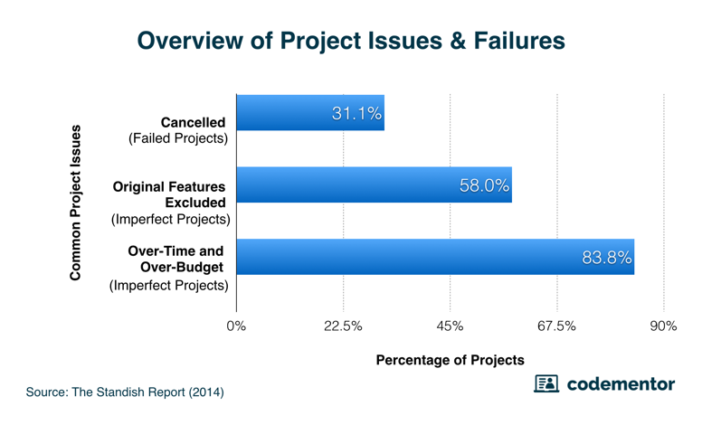The following 2014 Standish report depicts this failure problem. On it “a total of 365 respondents were surveyed, with a total of 8,380 software projects represented — only 16.2% of them turned out as “ideal projects." The following graph shows the overall breakdown of failed projects and imperfect projects. Keep in mind, the following categories are not mutually exclusive, and that over-time and over-budget were combined as they are closely linked together.”[8]

*1.5 Software Project Risks*

With IT Project Management being a subset of Project Management, we can follow the breadcrumbs to the failure cause of a project similarly, but they differ in a lot of aspects too. So what are the failure factors related to IT projects? There is a large array of reasons influencing and causing so many IT projects to fail like “Inadequate resources, overly aggressive timelines, underestimated costs, overlooked requirements, unanticipated complications, poor governance and human mistakes such as bad code”[9](this is the same as reference 5), but the one, which we want to address with this project, is the management’s lack of knowledge, how to act in certain situations. There are also a lot of cases when the management is out of touch with the projects or not up to date with a lot of new terms and concepts, which we would think are outliers and exceptions to the rule, but actually it is one of the main causes of projects failures[10].

On this paper[11] from Xavier University in Cincinnati, the IT Project risk factors were discussed relatively in detail. The table below shows the risks found by three different studies.

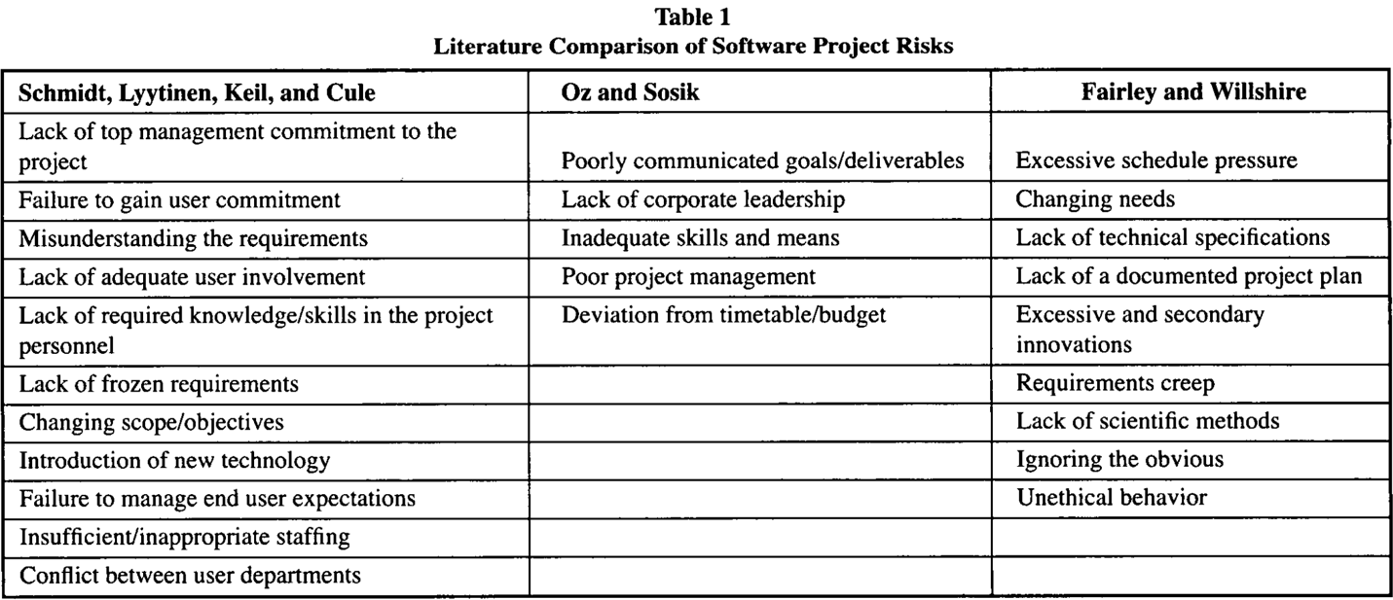

Interesting points to be aggregated taken into consideration for this thesis are the “Lack of required knowledge/skills in the project personnel” from “Schmidt, Lyytinen, Keild and Cule”, “Inadequate skills and means” and “Poor project management” from “Oz and Sosik”. So development of good enough managers, which is the goal of this project should contribute in a decrease of failures, as was also derived from this paper “In a study of knowledge transfer mechanisms, Karlsen and Gottschalk [10] found a significant correlation between serial, strategic, and expert transfer of knowledge and project success.”10

(Who we want to reach also)

*1.6 Other population subsets this app wants to reach (or a better synonym)*

Even though the further training of the actual managers is part of the population this serious game intends to extend itself to, there is also another subset of society we want present ourselves to and that is the young generation, who are still on the crossroads and unsure which career path they want to take. According to a survey [12]there is shortage of STEM (Science, Technology, Engineering, Mathematics) jobs in USA. “As of 2016, the U.S. had roughly 3 million more STEM jobs available than it had skilled workers to fill them, according to Randstad data.”[13] So our goal with the app is to make sure that the magnitude of T(Technology) jobs shortage, is lowered on the near future, also as a consequence of a young lady or mister coming across our project, and after investing a bit of time reading and interacting with the app, found out that the “it” she/he was looking for was IT.

*1.7 Why a serious game?*

Firstly a few definitions: Serious games are defined as games designed for a primary purpose other than pure entertainment[14]; Gamification is defined as application of game-design elements and game principles in non-game contexts[15].

As it was proven here [16] “The results we obtained so far lead us to believe that serious game design has a direct and indirect effect over student’s perceived acquired competency, which is mediated by student's engagement”, which means, that designing and creating a serious game, the teachings would reach a large(r) audience, while simultaneously providing a better information acquisition. The broader the crowd, the lesser the shortage of technological jobs mentioned above. Also if the enterprises worldwide have better informed projects managers, that alone would significantly decrease the percentage of failed projects.(reference the Kloppenborg paper here)

One of the main advantages of using an app to train employees is the reachability-effort ratio, i.e. a lot of users can be reached with very little effort. Training of the employees was before a process that required a lot of planning, a lot of logistics, to be able to teach a handful of people at a time, in contrast to remote training nowadays, which requires none of that, and simultaneously reaches far more members in a smaller timeframe. (Add Trainingsverwaltung data here)

The *ex-cathedra* way of schooling is outdated and the Gamification of project management is a far more superior way of teaching. As it was derived from this paper[17] “...the Gamification of the educational part of project management actually leads to better managed projects in the real business environment.”.

~~Write something else(Related Work)~~

*1.8 Gamification(Write something else)*

The process of Gamification in teaching a concept was conducted also in an study published on this paper[18] , where the agile project management technology, “Scrum” was taught to a group of 110 second year students. They all had different backgrounds (electrical engineering and computer science) but that was irrelevant, because the intention was to teach the participants the agile way of thinking, instead of diving deep into software or engineering related issues. As the conductors of the study found out “Gamification (or game-based learning) is motivating and helps bringing participants with different backgrounds together in project teams. The latter is what is needed in real development projects.” One of the other advantages noted on the paper was also the use of only one teacher.

There was a study[19]conducted that collected all the research papers describing the current state of the art of injecting Gamification in software management projects. In it there are a few take-home messages that would be used while designing this app:

1. It was concluded that “…half of the areas identified as project management areas evidence intervention with a Gamification approach…”, which means that teaching concepts of project management through a serious game is not a new concept, but nevertheless it is on its early stages.
2. Another conclusion of this study was that “…the software project management areas that explored Gamification more as an improvement strategy mainly propose improvement strategies, e.g. (a) teamwork conditions, (b) interaction between stakeholders, and (c) participation of team members in a software development project…”, which means that we can address another area, which is (re)learning of IT project management concepts and methodologies.
3. It was also concluded that “…the table of positions, badges, and point systems improve results and user participation…”. That supports our intention of adding a point system to the game.

There was another study [20] which oversaw all the research published that studied the introduction of Gamification in education, the context in which was applied and the game elements used. The researchers concluded that “true empirical research on the effectiveness of incorporating game elements in learning environments is still scarce”, which may sound negative but there is a lot of hope because it was concluded that “Gamification hast the potential to improve learning if it is well designed and used correctly”. One of the main reasons because Gamification in education is not advancing as it should have, is because the course instructors lack the necessary technological skills to implement, maintain and direct these relatively high-tech entities. No wonder the field where Gamification of education found the biggest adoption rate is Computer Science/IT.

**Related Work**

(Write about apps on the market that are alike to ours)

*2.1 Current similar apps on the market*

Since the serious game is going to be an Android app, the obvious first step was to explore the Google Play, in order to create an idea, what is the actual supply of apps similar to the one intended to create, and also their current stage of the development.

After inputting “Project Management Apps” on the search field, a very rich array of results came up. The top 100 apps were reviewed and were partitioned into lists according to their features. The majority of the suggestions were apps designed with the main purpose to track progress of projects, i.e. tools that the management can use to monitor task assignment and completion of the employees, the to-do lists of the project, a platform to arrange meetings etc. These particular apps are not related to this project, so they were discarded.

(Here write the Top 10. For the first 7 give a brief description. For the top 3 go into details)

*2.1.1 Best matches on the Google Play Store*

The family of apps that are of interest to our serious game, are the one that introduce and elucidate concepts of (IT) projects and their management, provide questions to the previous explained theory, and one of the most important characteristics searched for was the injection of gamification elements into it. Here is a list of the top results, that checked all/the majority of the marks:

1. Learn Project Management[21] ([Link](https://play.google.com/store/apps/details?id=com.quizmine.projectref_01))
   * The user has a rich offering of chapters like “Introduction to project management”, “Role of a project manager”, “Project basics” etc. When the user clicks on one of these subjects, a new window (find the app equivalent) opens where the user can choose between a tutorial about the field or opening the quiz about it.
     1. If the user opens up the tutorial, a list is presented, where all the topics that will be explained are displayed. Below this listing the user sees the above topics explained in more detail in bullet points listing
     2. If the user opens up the quiz, all the material explained on the tutorial section, is asked through a multiple choice questionnaire. A timer is also started with each question. When the time is up, the user is redirected to the next question, thus losing the ability to collect (more) points.
2. Software Project Management[22]: [Link](https://play.google.com/store/apps/details?id=com.faadooengineers.free_softwareprojectmanagement)
   * The user can choose between an abundant array of options on the main screen. They enhance the study experience and can go together with a good deal of moods. This allows him to interact with the app more frequently, increasing the learning curve and augmenting the information acquisition. The options and a short description of them is listed below:
     1. 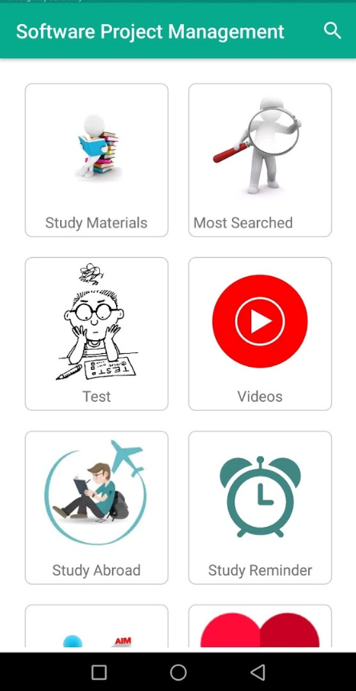Study Materials:
        + It is separated in three units, namely “Conventional Software Management”, “Software Management Process”, “Software Management Disciplines”. Each unit has a different amount of topics. When a topic is clicked, a window is opened with an explanation of it. Furthermore each topic can be seen offline, shared or inserted to favorites.
     2. Most Searched Topics:
        + A very rich and long scrollable list of topics is presented to the user. An interesting feature is that for each clicked topic, a window opens itself where the search result of it on “Faadoo”, “YouTube” and “Wikipedia” are revealed.
     3. Test
        + Here the user is provided a questionnaire of 10 questions. It has four alternatives and only one of them is right. When a choice is clicked and submitted an instant evaluation is displayed that says either “Wrong Answer, the correct one is: *Here comes the correct choice*” or “Right answer”.
     4. Videos
        + An amount of topics that are part of management of software projects are taught through video tutorials. It allows the user to get the information in an animated way.
     5. Study Abroad
        + Another interesting feature is the “Study abroad” option. It shows the top 5 countries with international students and for each it lists some reasons why to choose that particular destination, its popular courses and universities, application procedures on how to get a visa but also how to enroll in an university.
     6. Study Reminder
        + Thanks to this option a reminder can be set, and so the user will receive a notification when it is time to study.
     7. My Progress
        + It shows the reading progress of the user, i.e. the all of the topics that he as read.
     8. My Favorite
        + It lists all the topics marked as favorite by the user.
     9. More Books
        + It shows a list of related engineering and science learning games, like for example “Computer Science Apps”, “Electrical Engineering Apps”, which when clicked present a formation of that topic’s associated apps on Google Play.
3. Project Management: [Link](https://play.google.com/store/apps/details?id=app_projectmanagement.EN)
   * 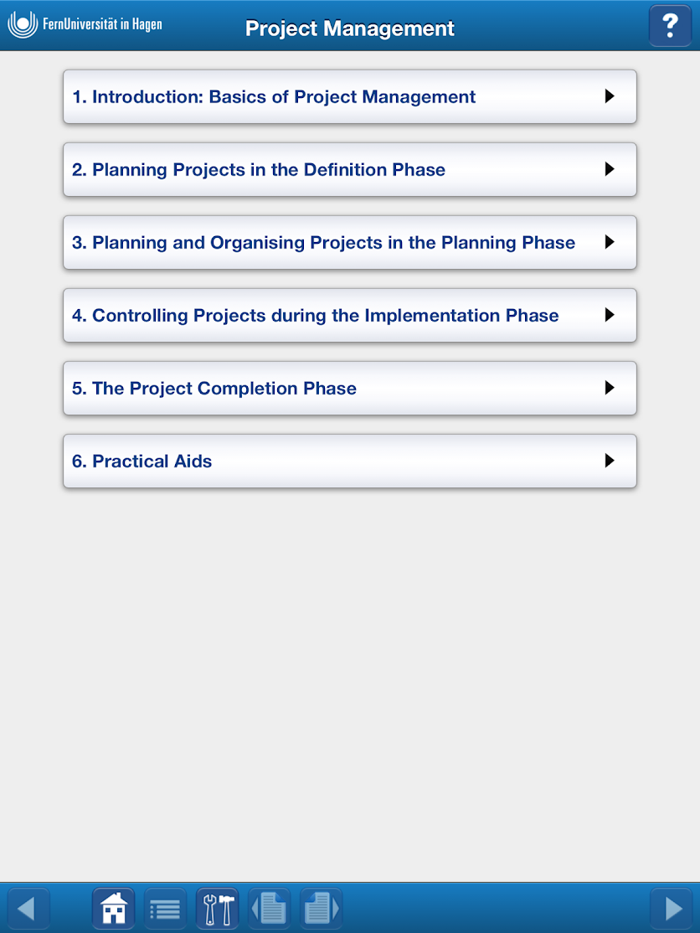A very well done educational game from the “FernUniversität in Hagen”. Here is the structure of the app:
     1. It is divided in chapters like “Introduction: Basics of Project Management”, “Planning and Organizing Projects in the Planning Phase” or “Practical Aids”.
     2. For each chapter there are subchapters which divide it into smaller pieces for better information acquisition.
     3. To further enhance it, each subchapter is divided into (on average 4) pages. As we can see the goal is to have snack sized pieces of information taught to the user.
     4. To provide another alternative to teaching, not just the plain old reading of a text, the app has introduced case studies, so that the user can absorb the context differently.
     5. An interesting feature is the “Practical Task”: The user is presented a question for which he can write an answer inside a Text Editor. With it the user sees where does his actual knowledge about the topic stand. Below the editor a “Sample Solution” is provided.
     6. The subchapter before the last is “Summary” which recapitulates the whole chapter briefly.
     7. The last subchapter is “Exercises”. On it a few multiple choice questions about the subjects explained in the previous subchapters are given to the user. After submitting, the user sees what were the correct ones. Also a link to the subchapter where the concept was explained is provided below the respective questionnaire.

*2.1.2 Other Serious Games not found on Google Playstore*

1. A company that provides a good deal of serious games tailored to customer requirements is “Designing Digitally”[23].
   * “AUGMENTED REALITY RESOURCE MANAGEMENT”[24] is the name of a game they created for a large construction enterprise, that wanted to address an ever occurring phenomenon inside their walls, where the managers were struggling with resource allocation in the majority of the from their undertaken projects.
     + Because the managers did not have access to computers during their quarterly training seminar, it was decided to create a mobile app, whose experience would be (syn: augmented) by introducing augmented reality elements.
     + On this serious game implementation the managers would virtually practice their on-field doings, i.e. task distribution to the (syn virtual) employees, material and equipment divided amongst all the actors participating in all parallel ongoing projects, all under time restriction and hence pressure.
     + All that was needed to participate in the game was a smartphone and some printed playing cards. When the phone camera was directed to a card, it was transformed into a movable 3D object, and by moving it with a finger, this card/resource was moved to another position and simultaneously allocated. The better the allocation, the more points did the user get.
     + The feedback for this game-based learning experience was very positive and the implementation praised by the costumer. The users/managers reported an increase in competence and recalling the information learned. The construction company intends to continue with the app during the next quarter seminar and hopes the experience would map itself in the real world projects undertaken by the managers.

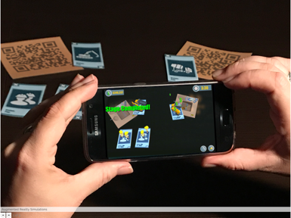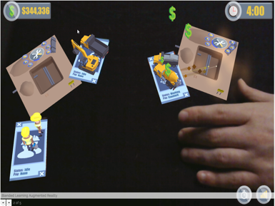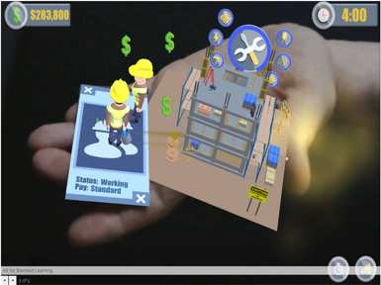

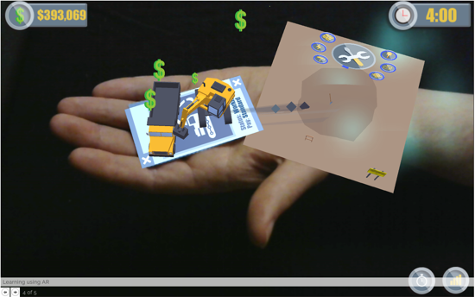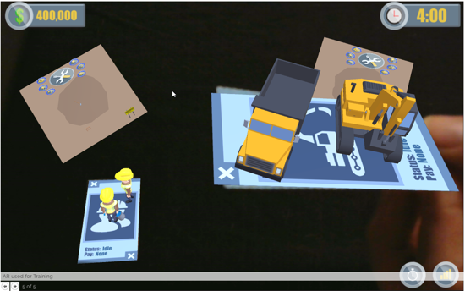

(INSERT THE PICTURES IN TABLE FORMAT, WITH DESCRIPTION TEXT)

* + “SIMULATED ETHICS”[25] is another app created by Designing Digitally Inc to address a delicate issue that the HR department in every company faces: Workplace ethics.
    - Due to budget constraints, it was not possible to organize seminars where subjects like harassment, misconduct etc. and the respective reaction paradigms would be discussed. That’s where an serious game comes to play
    - The issue would be attacked by creating a web-based App, so that it could be accessible to each company member. In it two reoccurring roles, namely “attacker” and “victim”, are presented in different scenarios of everyday work. For each (syn scenario) a few alternatives are presented, how an actor should react to the situation, and based on the answer provided by the user, the (syn outcome) changes.
    - The product was implemented into the company and used to school more than 20.000 employees about those delicate matters and how they should conduct themselves in their workplace.
    - 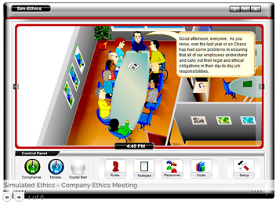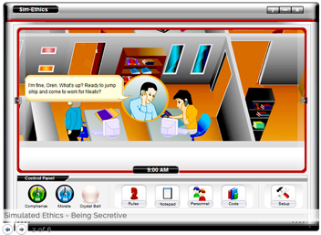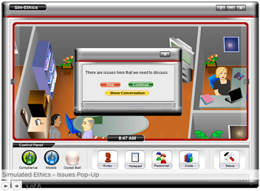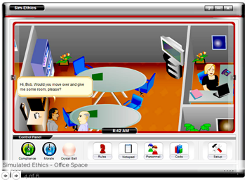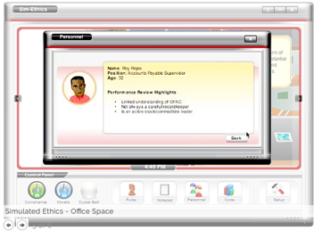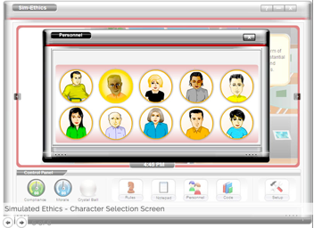

1. 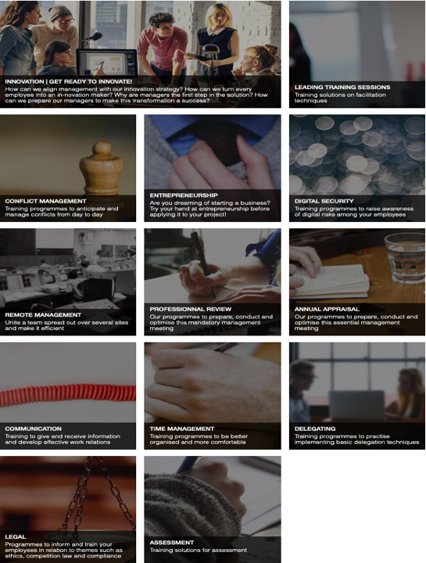Another software company which engages in creation of serious games is “Serious Games Store”[26].

The offer a plethora of subject based trainings programs like: Conflict Management, Time Management, Remote Management, Entrepreneurship, Communication, Delegation etc. The paradigm is to divide the teachings on each subject in three short and thus digestible 3D animated motion pictures so that the learning is not, for a lack of a better term, boring at all.

Some of these programs are:

* + Conflict Management: WRITE ABOUT CONFLICT MANAGEMENT(SCREENSHOT/PDF)
    - 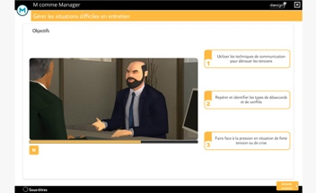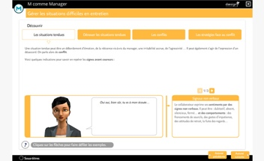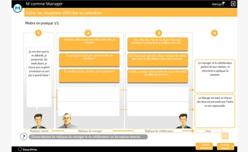
  + Time Management:
    - This training program is divided in three sections/situations: Organizing time, manage time and delegate a task. For each one of this situations an animated moving picture shows how a manager should behave when presented with a situation.
    - 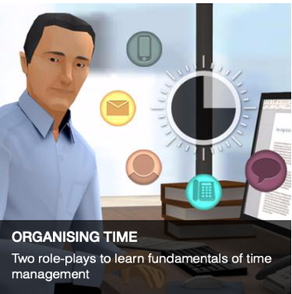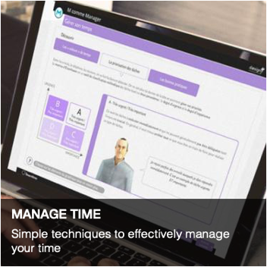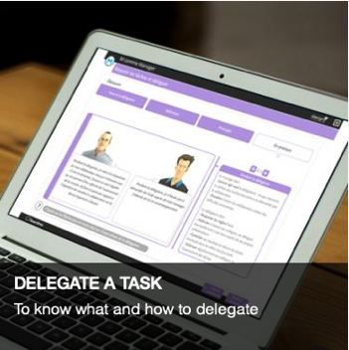
    - 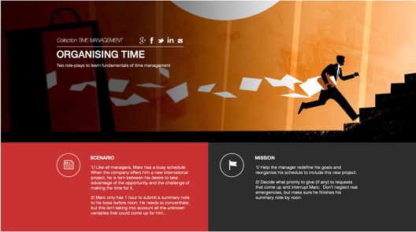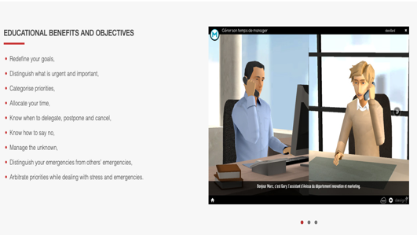

1. CIO Planspiel[27] is a software implementation from the Chair for Information Business Systems at the Technical University of Munich. It is intended as a learning platform for a practical course offered to enrolled informatics Master of Science students.
   * 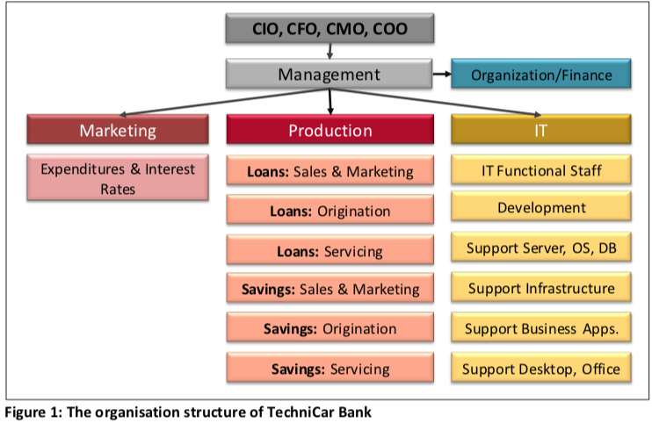In it the user/student takes the roles of: Chief Information Officer (CIO), Chief Financial Officer (CFO), Chief Marketing Officer (CMO) or Chief Operations Officer (COO) in a fictional company called “TechniCar Autobank”. The company is specialized in car financing and saving account. Like accustomed in manager training games the user is provided with diverse company resources and faces diverse situations, where he/she has to allocate the resources through his best judgement. The situations are interconnected so each decision taken should be calculated correctly as it will ignite a chain reaction. The implementation is web based but with no animation features or any other property seen on the previous two examples. The user is presented with a table, where he/she has to insert a value on an input field and in that way the resource allocation for that particular case is (synonym for done).
   * 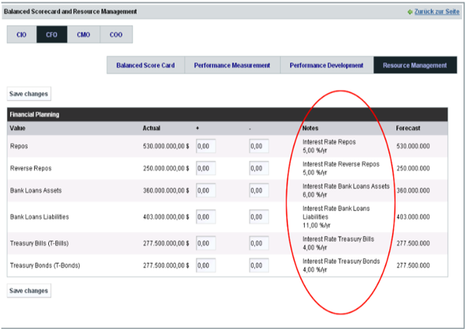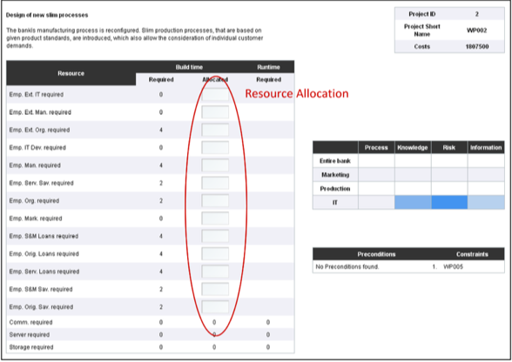

In the figures above

___________________________________________________________________

Theory

* 1. **Introduction**
  + On this chapter the basics, that will be explained more on the detail on the next chapters, are mentioned briefly. It starts by mentioning the purpose of the book, which is “to supplement the PMBOK® Guide with knowledge and practices that can improve the efficiency and effectiveness of software project managers, their management teams, and their project members.” Then it explains what a project is, continuing with what project management is and why it is so challenging. On the 4th and 5th subchapters the authors describe relationships between different PM entities. On the 4th is described the one between projects, programs, and portfolios, meanwhile on the 5th the one among project management, operations management, and organizational strategy. The subchapter 1.6 introduces the concept of “Business Value”, and the 1.7 explains the role of a project manager. The 8th subchapter explains what this book, namely PMBOK is and is not. Quality management is mentioned briefly on 1.9 as it will be gone more on detail on a whole chapter, the 8th one. The same is done on the 1.10 with “Project Life Cycles and Agile Methods” as they also have a designated chapter, namely the second one. The last subchapter of the first chapter explains software extension processes, i.e. inputs, tools and techniques, and outputs for each project management process.
  1. **Project Life Cycle and Organization**
* The second chapter analyzes how an organization and its structure influences a project and also the tools and techniques that are used for it. The first subchapter describes the organizational influences on project management and the information provided is divided in five further sections: Organizational Cultures and Styles, Organizational Communications, Organizational Structures, Organizational Process Assets and the last one is the section named “Enterprise Environmental Factors”. The second chapter gives concisely information about project stakeholders and governance. Even though, the matter is described shortly, its essence is explained certainly well. The third subchapter is called “Project Team”, and like the name suggests, it introduces the team entity of a project and all the different structures that it can take dependently on its members. While the first two subchapters provided information about the organization, the last one introduces the project life cycles as a concept. On its two sections it goes more into detail about its characteristics and phases respectively.
  1. **Project Management Processes for a Project**
* On this third chapter each of the five project management process groups (Initiating, Planning, Executing, Monitoring and Controlling, and Closing) has its designated subchapter where it is explained how they are incorporated into the management of software projects. The starting subchapter makes the distinction between process groups vs project phases and also the coexistence and interaction between the process groups mentioned above, hence the chapter name “Common Project Management Process Interactions”. The second one describes all the process groups graphically together, while also simultaneously describing the dependencies between them. The first process group, namely “Initiating Process Group”, starts the series of subchapters that go in detail about each one of them with 3.3. The other ones, i.e. Planning, Executing, Monitoring and Controlling, and Closing are explained relatively more in detail on subchapters 4,5,6,7 respectively. The subchapter “Project Information” describes the three types it is divided into, i.e. work performance data, work performance information, and work performance reports. The 47 identified project management processes from PMBOK(the original book, not this one: software edition) are mapped into 10 categories. Each one of them has its own chapter starting from the next one, namely chapter 4. They describe the inputs, tools and techniques, and outputs for most software projects.
  1. **Project Integration Management**
* 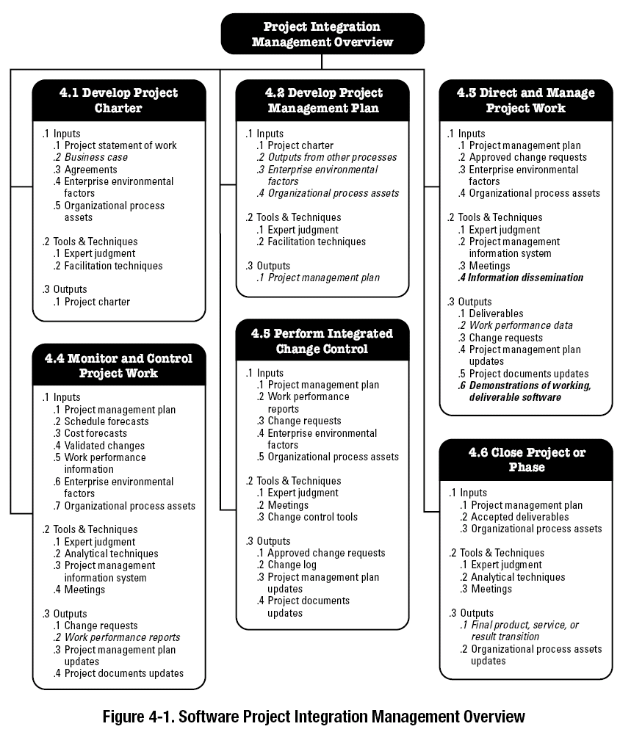The chapter is started by providing the definition of PIM on the PMBOK book. It is defined as the knowledge area that “processes and activities needed to identify, define, combine, unify, and coordinate the various processes and project management activities within the Project Management Process Groups”. To differentiate it, it doesn’t mean how software components are integrated in a system, but the integration of processes and activities on a project. The first step of Integration Management and hence the name of the first subchapter is “Develop Project Charter”. It allows the management entity to allocate enterprise resources to the (software) project. The second subchapter is “Develop Project Management Plan” where the whole project is divided on subprojects, for each of those is developed a plan with all inputs, outputs, tools and techniques , and lastly all of these plans are pieced together into a master plan. The following four chapters, simultaneously steps of PIM are: “Direct and Manage Project Work, Monitor and Control Project Work, Perform Integrated Change Control and Close Project or Phase”. For each of these sections the inputs, outputs, tools and techniques are to be written.
  1. **Project Scope Management**
* 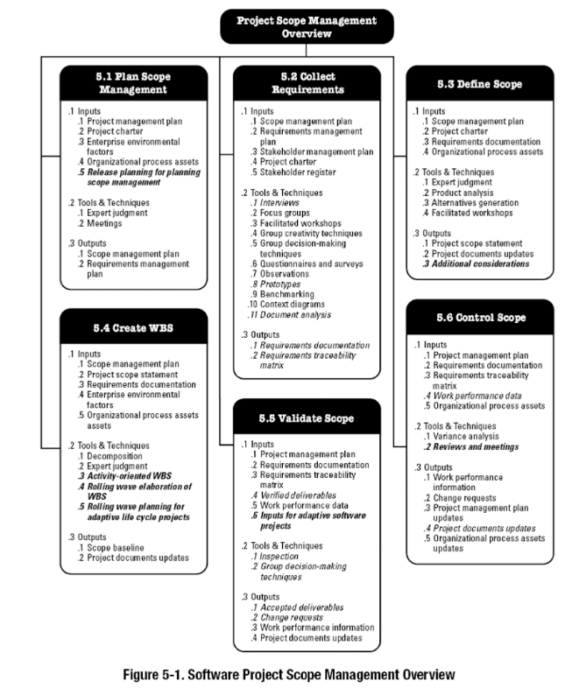Scope Management is defined on PMBOK as the entity that “includes the processes required to ensure that the project includes all the work required, and only the work required, to complete the project successfully.” The same definition can be used also for this extension, i.e. the software PM. Then the authors differentiate between product scope and project scope, and their bidirectional dependency. As is the custom of each of the 10 categories of the project management processes, every step of a category gets its own subchapter where the inputs, outputs, tools and techniques for every one of them are also to be written. The first section is the “Plan Scope Management” which is defined as the “process of planning for, defining, and documenting stakeholder needs to meet the project objectives”. The other step is called “Collect Requirements”, a very well-known step to developers, also known as “Requirements Elicitation”. It is very important that the requirements are clear and well understood, even though as it is known on software world : “change is the only constant”, and the they will very likely change during a projects lifetime. After this process is accomplished, the team creates a detailed description of project and product, a step known by the name “Define Scope”. On the section 5.4 of PMBOK, the original one but also on the software extension, the Work Breakdown Structures, also known by the abbreviation WBS, are introduced. The next section is concerned with validating the scope. It starts by differentiating between validation and verification, and then like usual the inputs, outputs, tools and techniques are mentioned. The last step is called “Control Scope”, monitors, like the name suggests, the “status of the project and product scope and managing changes to the scope baseline”.
  1. **Project Time Management**
* 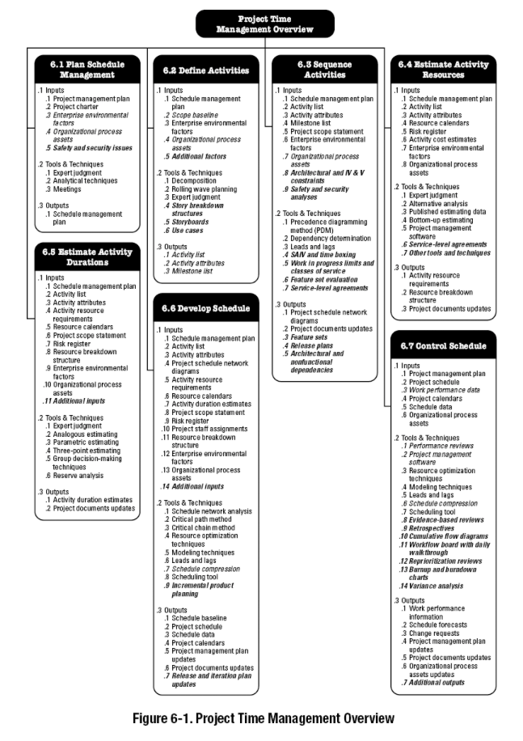As mentioned, on the previous sections(reference here), a lot of project are often delayed and one of the main reasons of project failures is time management.(Write also something about timeframe estimation, the additional resources that are required with all these delays etc.) It can be aggregated to seven processes, and for each one of them the authors have devised a chapter. The first one, on the same fashion as in scope management, starts with the planning, and is called “Plan Schedule Management”. All the activities that are going to produce the deliverables are defined on the second subchapter. The on the previous section defined activities and their dependencies, now are identified and documented on the third section, known by the name “Sequence Activities”. Like mentioned, an enterprise allocates resources to a project. The mapping of resources to activities is done on the 4th step of PTM. Determining the duration of each activity is an art form on itself. Even though two projects can be compared in terms of magnitude, complexity etc. that ratio does not manifest itself on the duration. On section 6.5 this subject is discussed. The 6th section, namely “Develop Schedule” hints how to create it, by always keeping in mind that the requirements will change, and flexibility should be the essence of it. The last step is as usual the controlling, which is not always that easy, especially on projects that don’t use the waterfall model, or any linear one for that matter. The “How To ” is given briefly on this closing subchapter.
  1. **Project Cost Management**
* 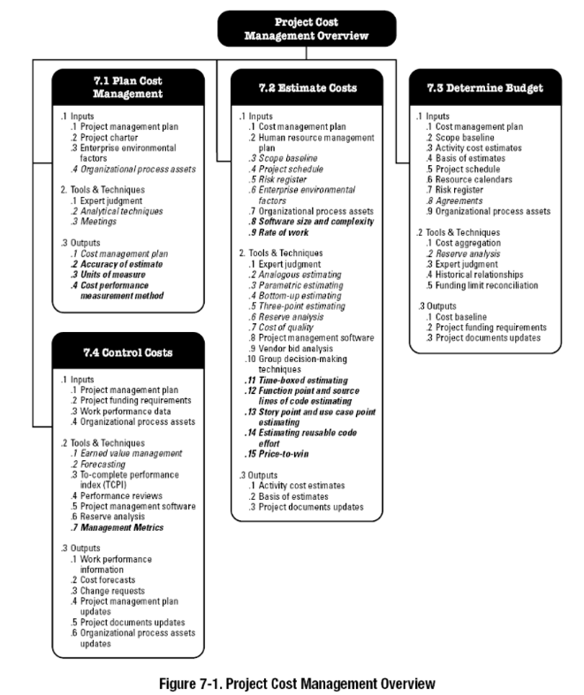This is one of the most important disciplines of project management. Managers don’t want to repeat the “NHS Connecting for Health”, which cost the United Kingdom taxpayers an estimated £12bn from an original cost estimation of £2.3bn or other sister projects failed[28]. If this could be somehow tolerated by a government or a big enterprise, for a small to medium sized company, a failure can mean total shutdown. The first step, as usual, is to plan the management of costs. It includes the foundation costs, the ones during the development and eventually the one for maintenance after the delivery. After each type of cost is defined the next step is to estimate the each and every one of them. This one is done on the second step of PCM, obviously called “Estimate Costs”. After this step, the management allocates a budget to the project, a procedure described on the third subchapter, with all the respective inputs, outputs, tools and techniques. Costs control is the final step, in which, keeping in mind that the requirements are always changing, they don’t initiate out of scope costs, or at least, if arisen, to keep them at a minimum.
  1. **Project Quality Management**
* 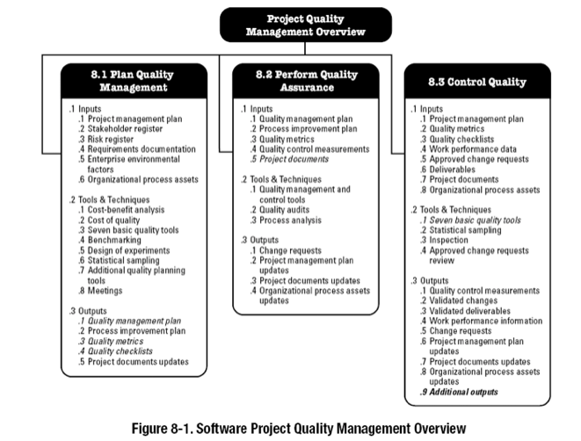As introduced on PMBOK PQM “ …includes the processes and activities of the performing organization that determine quality policies, objectives, and responsibilities so that the project will satisfy the needs for which it was undertaken.” It is divided in three sections: “Plan Quality Management, Perform Quality Assurance and Control Quality”. Each one of them gets a subchapter. The first step, as mentioned, is to plan quality management. It is defined as “The process of identifying quality requirements and/or standards for the project and its deliverables and documenting how the project will demonstrate compliance with quality requirements.” It defines a baseline array of quality requirements that a deliverable must have, and plays the fine art of balancing the tradeoffs between features, schedule and cost amongst others. The following step is “Perform Quality Assurance”. On it the appropriate standards and milestones are defined, that every partaking process has to accomplish. The next and final step, works with the mantra “measure, control, and report”. In it is evaluated if these standards are met and then these assessments are documented. Even though some standards may be more powerful than some others on their global definition, to a project is very important that the quality conforms the client’s expectations.
  1. **Project Human Resource Management**
* 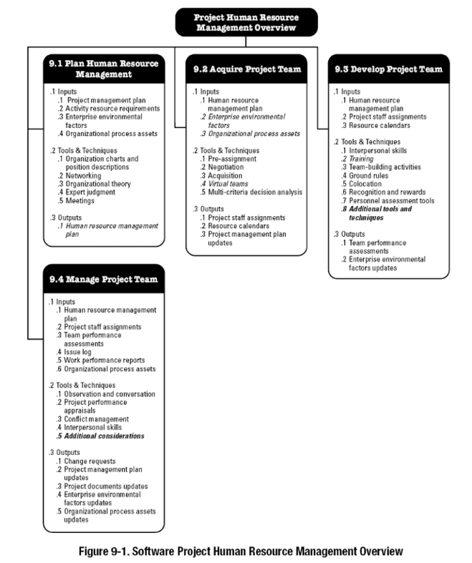Project HR Management is defined on PMBOK “… includes the processes that organize, manage, and lead the project team.” But software “workers” or “employees” differ in a lot of aspects from the “normal” ones. They usually have a better understanding of the technical facets of a project, than the manager. As it was stated in the introduction page of software HR management chapter: “Successful software project managers typically put less emphasis on directing the work and more on facilitating the efficiency and effectiveness of project teams.” The first step described is the planning of HR Management, in which the roles and responsibilities, but also the required skills are laid out. Aspects that are also considered is the report structure, i.e. “who reports to whom”. The next very important step is to “Acquire Project Team”. The software development world is mostly about novelty, in other words creating an entity from requirements collected by a client, who usually doesn’t possess a technical background. That requires a team of individuals, who have to be invested in the undertaking. Because of that it is very important that the pieces chosen to form the team, not only carry with them the necessary tech skills but also fit together and are on the same wavelength. The next step is to put together the team after finding the pieces, hence the naming of the step “Develop Project Team”. The goal is to be able to go through the Tuckman's stages of group developments[29], ”forming–storming–norming-performing”, as smoothly and quickly as possible. Some of the techniques used by software project managers include: pair programming, test driven development(TDD),colocation and also developing trust. The very last step is “Manage Project Team”, where the delicate issue of performance measuring is discussed. Because software development is a collaborative endeavor, the strong dependency makes grading individual contribute highly difficult. Measuring team production rate is the way to go. That will motivate all the members to help each other more.
  1. **Project Communications Management**
* 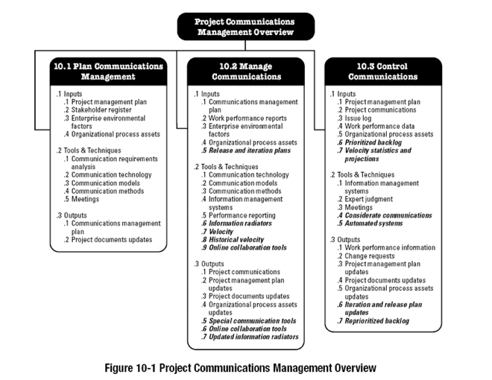PCM is defined on PMBOK as “Project Communications Management includes the processes that are required to ensure timely and appropriate planning, collection, creation, distribution, storage, retrieval, management, control, monitoring, and the ultimate disposition of project information”. Like mentioned on the previous chapter, developing a solid communication structure is paramount to the managers, because software development is a collaborative problem-solving endeavor. The communication structure should not only be established between the team, but also with the stakeholders of the undertaking. As stated on the first subchapter, called “Plan Communications Management”, face-to-face (FTF) communication is the preferred way. On collocated teams that is very well doable and should be incented. Thanks to technology, like video calling, this synchronous way of information exchange is also achievable in this day and age. The next step is called “Manage Communications Management”, and in it the different tools and techniques are discussed, like for example information radiators. They provide information about tasks accomplished, the ones in development phase and also the ones still to be accomplished. The last step is known by the name “Control Communications”. On this subchapter it is discussed how this communication and reporting to stakeholders structure is performing and the tools and techniques used. For predictive life cycles, milestones are a very often used metric, because of its simplicity but the majority of software projects these days use adaptive life cycle models, hence the milestones are not suited as measurement. Number but also importance of accomplished user stories which increment the product is used instead.
  1. **Project Risk Management**
* 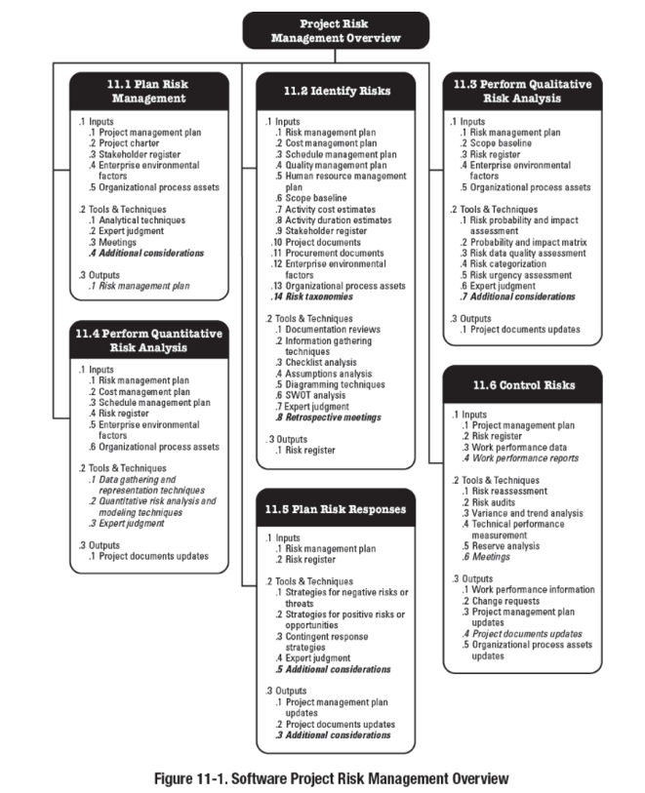PRM is defined on PMBOK as “Project Risk Management includes the processes of conducting risk management planning, identification, analysis, response planning, and controlling risk on a project”. One of the main duties of a project manager is risk mitigation, because hazardous factors are always to be accounted for and the uncertainty, that they carry with themselves makes the job that more difficult but at the same time interesting. The first step is to plan for risk management. Before a project is given the green light, risk is an aspect that is considered. Because of their iterative nature, it is relatively easy on adaptive life cycle models, to mitigate risks, because the team can choose the next step on the backlog, and decide how to deal with the respective risk. After planning comes the doing, and the first step of dealing of mitigation is to identify the type, as described on the subchapter 2 called “Identify Risks”. The ambiguousness makes the identification that much hard, but the most common types are: technical, safety, security, team, schedule, costs, costumers and stakeholders. The next step of PRM is to perform qualitative risk analysis, i.e. to predict the probability and impact of the future risks. Here is where experience of a manager comes into play. After qualifying it, the manager hast to conduct a quantification analysis. Usually the monetary value is used as gauge. On the next subchapter called “Plan Risk Responses”, an array of solutions for each identified risk is created. The risk exposure of an untreated risk, the residual risk and the cost of risk treatment is calculated. If the impact of the risk is less than the cost of treatment than the risk is accepted. How to control risks is discussed on the closing section of PRM. Various threshold limits are settled from the management, like for example defects per thousand lines of code (KLOC). One other way of controlling it is through meetings like daily, retrospective etc.
  1. **Project Procurement Management**
* 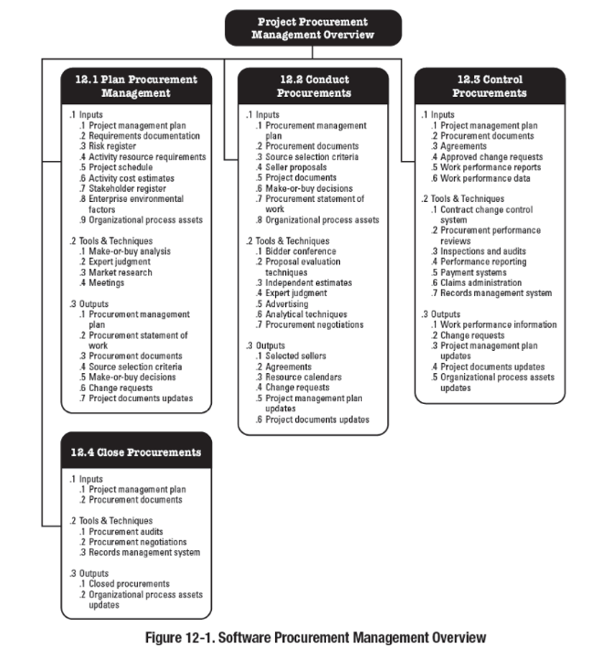PCM is defined on PMBOK as “Project Procurement Management includes the processes necessary to purchase or acquire products, services, or results needed from outside the project team. The organization can be either the buyer or seller of the products, services, or results of a project.” While large organizations and governments have designated departments that deal with it on a more larger scale, procurement happens also on medium to small enterprises, and usually the handling of it is a responsibility of the manager. The first step, as usual, is to plan it. After thoroughly studying the situation that needs to be solved and the market alternatives, the management should document the process and then come to a make or buy decision. The steps are usually: Identify suppliers, come up with a statement of objective or statement of work, establish proposal evaluation criteria and lastly prepare terms and conditions. After deciding, the next logical step is to “Conduct Procurements”. The management, which is the buyer, contacts the selling enterprise and the contract negotiations ought to start. Costs, which usually is the most important and delicate aspect, is discussed. But also technical support, its timeline, delivery procedure etc. are also taken into account and agreed upon. The next section called “Control Procurements”, describes exactly what the name suggests. Software is constantly updating and newer versions are released periodically. To be able to yield full performance constantly a lot of effort should be put into incorporating these updates, and if necessary, patching should also be considered. The closing step is called, of course, “Close Procurements”. A manager should always keep in mind that after the Go Live of a project, it usually requires maintenance, and the support of the external acquired software component, used to build the product, can expire.
  1. **Project Stakeholder Management**

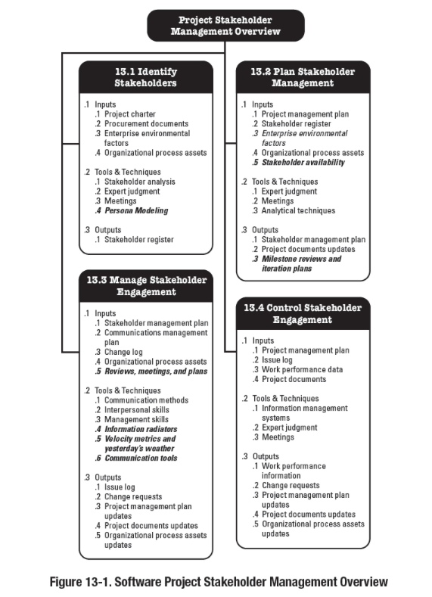

**(Write about the Project Stakeholder Management)**

Development

*4.1 Introduction to Android Studio*

At the start of the thesis, after the rough idea of the program was agreed upon, the next step was to choose an development environment. Because mobile apps are the hype in this day and age, it was decided to implement our solution using Android Studio. This was a very beneficiary because it also added another element to my development portfolio.

The first 3 weeks were designated for diving into AS world by reading the documentation, and also partaking into a lot of online tutorials. The first one was “Android - Studio”[30] from tutorialspoint.com(See Picture 1). After concluding that, the other one was “Android Developer Fundamentals Course”[31] from Google Developers. The third step was reading the documentation provided by developer.android.com. They helped myself tremendously and hopefully would come in handy when the development phase would begin.

*4.2 Introduction and “brief” engagement with Cocos Creator*

After the Kick-Off Presentation and the completion of the Introduction, Related Work and Theory sections to almost their entirety, the development phase could start. A good idea was to find a framework that would aid with the animation of the game. The one who looked the most promising was CocosCreator[32]. So the next two weeks were used to get an introduction into the framework and to create an “Hello World” application.

*4.3 Game Design*

The paradigm of the app is “Learning by playing”. It is the core value of a serious game and during the designing of the games, it was repeated constantly as to not lose sight of it. On that note, there are a lot of elements of gamification that sometimes get interchanged and regarded as serious game ones, but asking repeatedly “is the user learning by having fun?” always redirects to the right route.

The strategy behind this android app is pretty simple:

* Let the user play an easy minigame, initiating cognitive engagement
* KISS: Keep it(the game) short and simple, not mentally challenging
* Give instant feedback, especially negative one, to ignite a sense of competition user vs app
* After a successful attempt, give an relatively enthusiastic positive feedback and directly start with the teaching of a concept intended. Because of the small window between the positive feedback and the teaching, subconsciously a positive relationship will be created with the concept
* It is also very important to keep the teaching relatively small, as the user might be tempted to go to the next minigame and not read it. The feel good chemicals released from the brain during playing[33], make him/her crave the next minigame instead of a long boring chain of characters, that take a whole page. If however a small text is provided, containing just the essence, and enriched with bullet points lists, than the teaching has a very big chance to be read and understood.

As mentioned on the “Related Work” section, there is a plethora of apps to be found, which teach the same concepts and theory, but none of them in a very fun and engaging way. The mantra behind this project is to engage the user as much as possible, both intellectually but also to a certain degree, physically, i.e. by interacting with the screen of the device. Touching items, moving them around to their designated place, getting instantaneous positive or negative feedback, are all crucial components of the implementation.

*4.4 Where do the game elements come from?*

The teachings of the app are extracted from the PMBOK(reference) but also from interesting pictures, charts, i.e. graphical representations of different concepts found online. Programmers know that reusing content available adds to the quality of the final product. The content found adds a nuance of humor, thus engaging the user more into playing.

The goal of the design is to subconsciously map inside the brain of the user, the game to an activity that brings fun, not one that merely shows concepts a software project manager should know at the tips of his fingers. That would create a sense of anxiety for the interactor with the app, especially if he/she is an aspiring PM, or an actual one which wants to learn new concepts or relearn the ones acquired sometimes ago.

By using content found online, designed not by not a single set of creators, adds a great deal of quality to the minigame.

* 1. *How does the app look*

*4.5.1 First Screen*

* 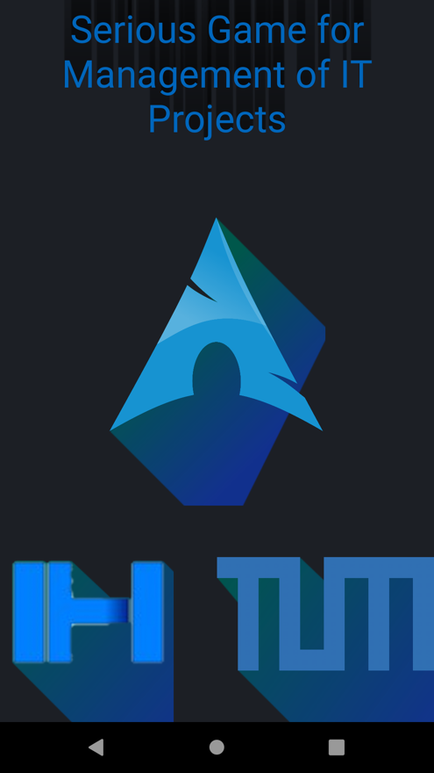The start screen of the app is depicted on the right. For the design part it was decided to keep it as simple as it could be kept, i.e. as few elements as possible and as many as necessary were to be added to the screen. All the elements are padded with shadows. The text one has just a dark one directed to the top. The logo ones have a color changing shadow. It stars with a green pigment and ends up with an blue-lilac one.
* On the upper part of the screen the title of the project is displayed. It contains a blue text color and, as mentioned above, with a tad bit of a shadow directed to the top.
* On the middle the logo of the app is to be seen. If it looks familiar, it is because the symbol of Arch Linux[34] was used. The design of it is very simple and elegant, and for those reasons, it was decided to add it to the app as the (un)official logo.
* On the lower right part of the screen stands the logo of the Technical University of Munich. Since this project is a result, or better said, a section of the bachelor thesis at this particular university, it was considered meaningful to add it to the welcome screen.
* On the lower left part of the screen the logo of the developer, Ixhen Hasani, was added. Adding just the title, logo of the app and then the one of the university would create a straight line between those tree. From an artful conception point of view that would be an somehow acceptable but too simple design. Not very optimal as a first glimpse for the app. Hence the decision to add another element at the bottom.
* A five seconds countdown timer is added to the solution, which enables the transition from the welcome/first screen to the second one. This could have also been done through a button, but as mentioned above, the goal was to keep the view as simple as possible. Five seconds should be a long enough time to perceive all the items, but also short enough to not bore the user.

*4.5.2 Second Screen*

* 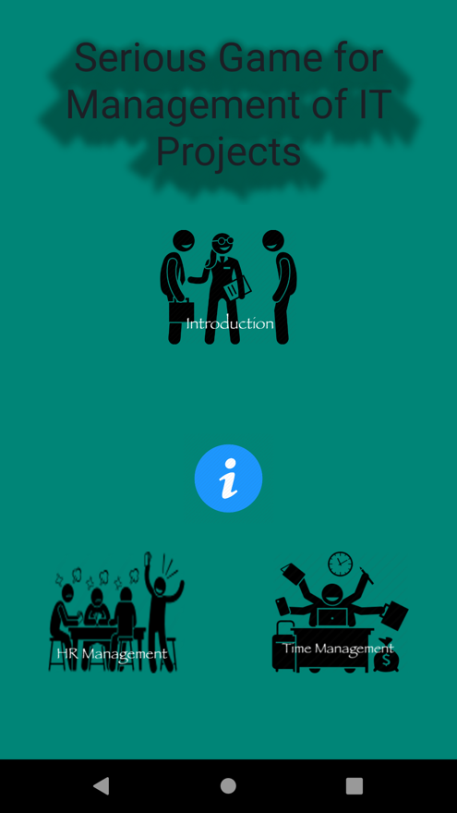On the second view, the design has some significant differences to the first one, but not that big in magnitude. The first obvious change is the background color. The black background serves its purpose very well as the first interaction screen backdrop color. But for all the other screens of this app it was decided to go with one of the most used android background colors. This green pigment is not hard on the eyes and gives a sense of tranquility.

Like in the first one, the title of the project is located on the upper screen. Not it has a different shadowing, same in shade but the direction is to the bottom and sides.

In the middle of the screen an info button is located. Equidistantly to it, three icons are situated. They represent the three chapters from the PMBOK Software Extension book, that were selected for the version 1.0 of the game, namely: “Introduction”, “Human Resource Management”, ”Time Management”.

Like mentioned, each one of this chapters, or better said, their content will be taught by playing a game. One each chapter icon, but also on the info button one, Click Event Listeners are attached. So when the user clicks one of them, he/she will be redirected to the each chapter’s game, or on the info screen in case he/she clicks on the middle graphic image.

The user has the option of playing each one of the games by tapping at the labeled boxes, and by doing that the minigame of the chapter will start.

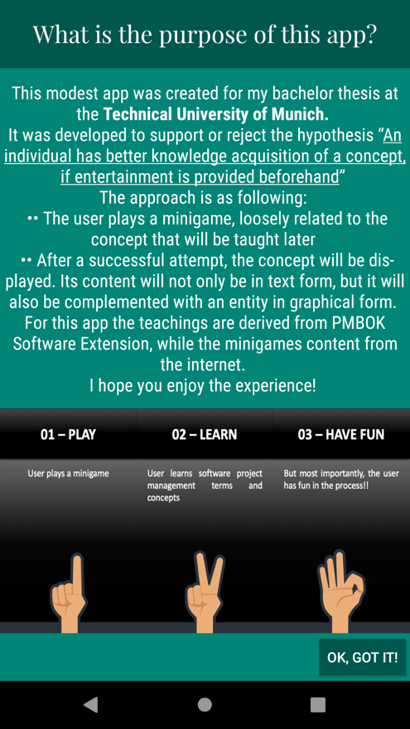

*4.5.3 Info Screen*

* The picture on the right shows the screen that will be opened, when the info button is going to be clicked. The layout will stay the same for each of the views, whose purpose is to explain a concept. On the top part of the screen a title bar is positioned. In this particular screen, the info one, the caption “What is the purpose of this app” is to be seen.
* It is followed by a text section. In it the purpose of the app is described briefly, but also the mantra of the game. As mentioned the sequence is: user plays, then he learns the concept, all of it by having fun.
* The screen segment below it, it’s a graphical representation of the above in text form described concept. This will be seen on the explanatory views of each respective game. Even though, the text section contains way less characters than a normal one, the user can be tempted to skip it. But by inserting a visual depiction of the in text form described concept, he/she would very likely go back to read it again. Even if that doesn’t happen, the picture contains the essence of what was written a little bit more elaborately on the previous section.
* On the very bottom, a button is located. It goes with the text “OK, GOT IT”, which when clicked, redirect the user to the second screen, i.e. the one where all the icons are displayed(see section 4.5.2 Second Screen).

*4.5.4 Introduction Chapter Game*

4.5.4.1 Game Content

* 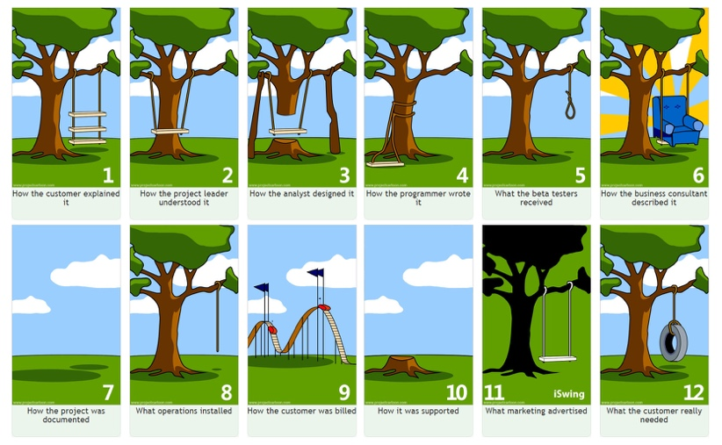This chapter on the book presents the reader with the core concepts of management of software projects. For the game a very popular and playful graphical representation of different points of view of a final product/software projects was chosen(see Figure[35] on the right).
* The twelve illustration sections show to a certain degree the real world actuality of a project, how it is understood, designed, sold etc. From this totality, four sets of three pictures were formed. By doing that, four minigames of “Introduction” chapter can be created. So the minigames are kept small, and four concepts can be taught after a successful attempt at each minigame.

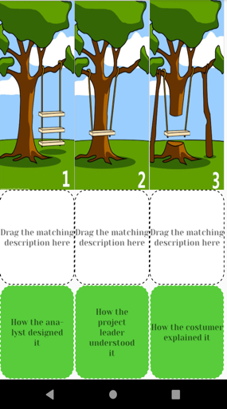4.5.4.2 Game View

The first minigame of the Introduction chapter is depicted on the figure to the left. User can go to it by tapping the top icon on the second screen(see section 4.5.2 Second Screen).It has three main sections:

1. The top one shows three pictures, with a similar background and entities, i.e. the tree and the swing. They all differ on the relationship between these two main actors.
2. The middle one is a placeholder for the descriptions which match the picture above them. They are all labeled with the same text “Drag the matching description here”
3. The bottom section contains three descriptions who ought to be mapped to each picture.

* None of the pictures of the upper section are interactable. There are no event listeners attached to them, as they direct the positioning of the description boxes.
* 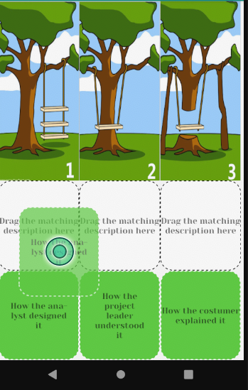On each of the entities on the bottom section(called Text View on Android Studio), onLongClick-EventListeners were attached, so that when the user presses them for more than a fragment of a second, they become draggable. It was decided to use onLongClick instead of onTouch so that it can be assured, that the user intended to interact with the element, and it wasn’t an accidental contact.

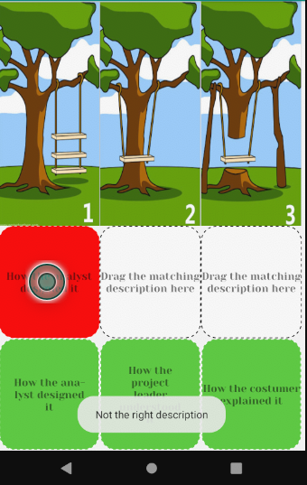As soon as an element of the bottom row is touched, the whole entity is movable, i.e. the box with the text centered (see figure on the left). It can be dragged to each of the rectangles on the middle section.

There it will be proved if the description dragged matches the one expected, i.e. the one that correlates with the picture above it.

* 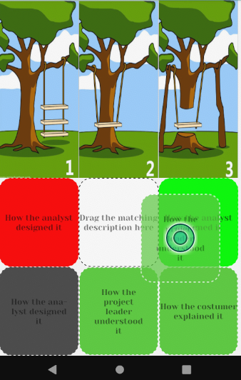If we don’t have a match then the box becomes red and a message “Not the right description” pops up. The box stays red and still accepts elements to be dragged in it.(See left picture on the bottom). The dragged element goes to its original place.
* In the case that we drag the element to the right frame, i.e. if we have a match, then the middle box becomes green and barriers the text that was dragged from the rectangle below(See middle picture on the bottom).
  + - The coloring takes place after the user has dropped it. No hint is given while the item is dragged. This is simultaneously the text that correlates with the picture above. The element below becomes gray and is not draggable anymore. Also the now green middle box accepts no more elements to be dragged inside it.

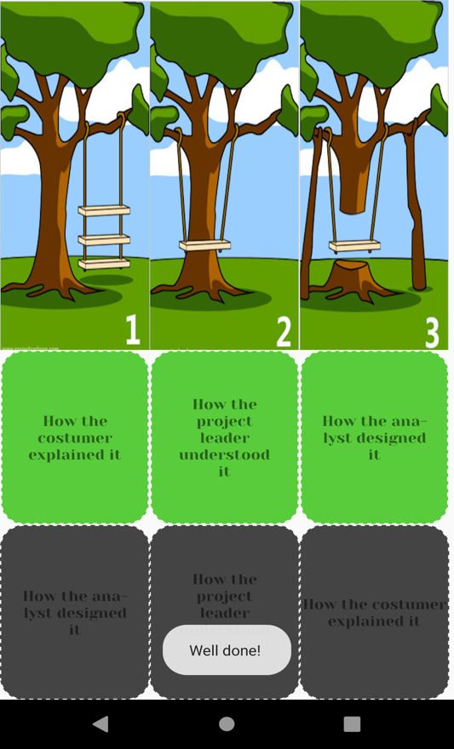If the items are dragged to their designated places, like on the picture above, a “Well done!” message will be shown to the bottom of the screen.

Then the user will be redirected to the next view, the lesson explanation one.

4.5.4.3 Explanation View

The layout of the concept explanation screen is, like mentioned on section 4.5.3 “Info Screen”, the same for each explanation screen regardless of the game. Its content is changed accordingly but the structure is always the same:

* The title "What is Project Management" is visible at the upper part of the section.
* Below the title bar, the definition of project management is given on text form. Also its five pillars, aka the five process groups are written in list form.
  + - * The third section from the top is the graphical representation one. In it once again the five groups are displayed this time in a chain entity. It should represent that they are all interconnected to each other.

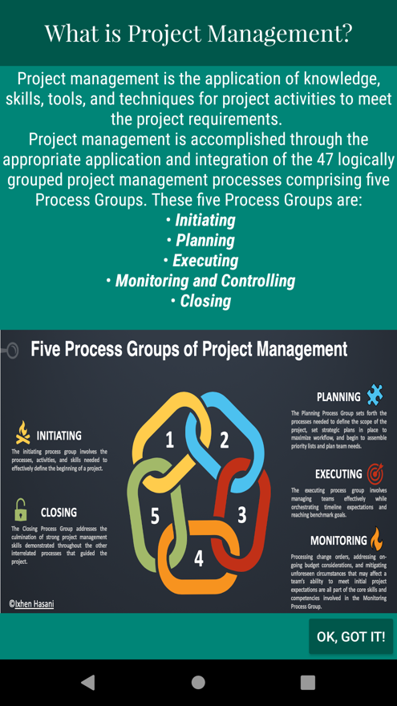For each stage a small explanation/definition is given.

The most important goal is that the five process groups can be recalled. Their definitions are not of a paramount importance, but nevertheless not that unimportant.

* + - * As usually, on the bottom part of the screen the “OK, GOT IT!” button is to be found. When clicked it redirect the user to the second screen, i.e. the one where all the icons are displayed(see section 4.5.2 Second Screen).

*4.5.5 Human Resource Management Chapter Game*

4.5.5.1 Game Content

* For the HR Management Chapter, it was thought as meaningful to provide a game where real world entities were the main pieces. Because SCRUM[36] is one of the most used frameworks in the industry the last years, it was decided to create an interaction with the user by introducing him/her to the defined scrum roles and their definitions.
* To add a little more game elements and not just show scrum role icons with their respective job descriptions, some other professions, very popular on a lot of real world company departments, but not scrum-related, were included.

4.5.5.2 Game View

* 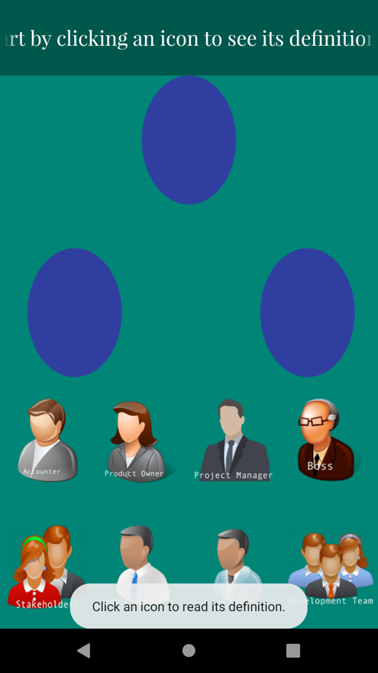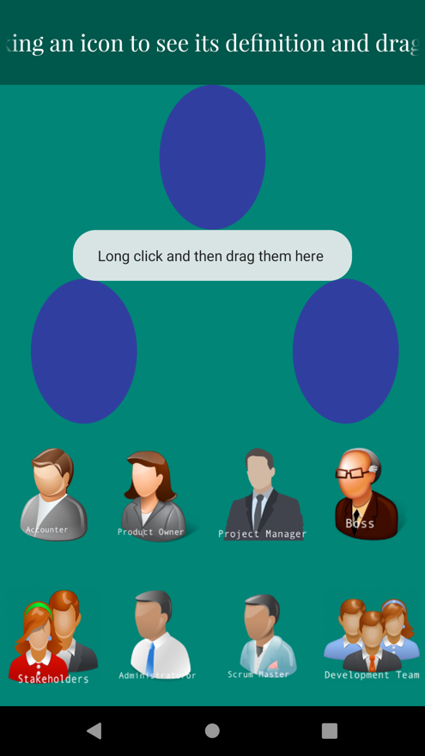When the HR Management icon is clicked on the Second Screen of the app, the user is redirected to the game. The screen on the left shows directly a message box at the bottom with the description “Click an icon to read its definition.” A timer is set, to pop a message on the middle of the icon placeholders(more on that latter), with the message “Long click and then drag them here”. So in the first three seconds of interaction with the game, the user learns what is to be done.

On that note, on the upper part of the screen, an permanently rotating title “Start by clicking an icon to see its definition and drag it in the middle, if you think it is a Scrum Role. GOOD LUCK!!!” is shown. Now that all the hints are given, all that remains for the user is to start clicking the icons, to read their definitions and decide which items are to be dragged in the middle.

On the bottom section two rows of four entities are displayed, namely : Accounter, Product Owner, Project Manager, Boss, Stakeholders, Administrator and lastly Development Team.

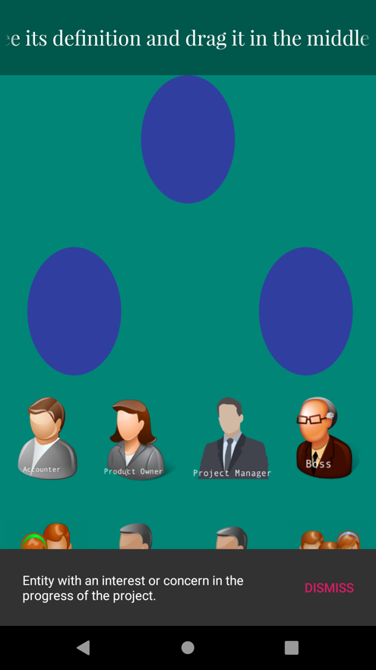

On the picture on the left is displayed what happens when the user clicks on the Stakeholders icon. A message “Entity with an interest or concern in the progress of the project” is displayed. It is the definition of that particular role. The same can be done for each one of the eight icons at the bottom.

When the user clicks an element at the bottom long enough, it becomes draggable.

References/Footnotes

1. https://searchcio.techtarget.com/definition/project-management
2. https://www.projectmanager.com/blog/history-project-management
3. https://en.wikipedia.org/wiki/Software_project_management
4. https://searchcio.techtarget.com/definition/IT-project-management
5. Tesch, D., Kloppenborg, T. J., & Frolick, M. N. (2007). IT PROJECT RISK FACTORS : THE PROJECT MANAGEMENT PROFESSIONALS PERSPECTIVE. *Journal of Computer Information Systems*, *47*(4), 61–70. https://doi.org/10.1080/08874417.2007.11645981
6. https://www.cio.com.au/article/625522/why-it-projects-still-fail/
7. https://faethcoaching.com/it-project-failure-rates-facts-and-reasons/
8. https://www.codementor.io/blog/software-projects-failure-rate-success-factors-1nqch57orj
9. https://www.cio.com.au/article/625522/why-it-projects-still-fail/
10. https://www.objectstyle.com/agile/software-projects-failure-statistics-and-reasons
11. Tesch, D., Kloppenborg, T. J., & Frolick, M. N. (2007). IT PROJECT RISK FACTORS : THE PROJECT MANAGEMENT PROFESSIONALS PERSPECTIVE. *Journal of Computer Information Systems*, *47*(4), 61–70. https://doi.org/10.1080/08874417.2007.11645981
12. https://www.randstadusa.com/about/news/employers-must-redefine-stem-to-attract-future-talent-according-to-new-randstad-us-data/
13. https://www.cnbc.com/2017/08/23/why-we-have-a-shortage-of-tech-workers-in-the-u-s.html
14. https://en.wikipedia.org/wiki/Serious_game
15. https://en.wikipedia.org/wiki/Gamification
16. Bonazzi, Riccardo & Missonier, Stéphanie & Jaccard, Dominique & Bienz, Pius & Fritscher, Boris & Fernandes, Emmanuel. (2011). Analysis of Serious Games Implementation for Project Management Courses. 10.1007/978-3-7908-2789-7_53
17. Briers, B. (2013). The gamification of project management. Paper presented at PMI® Global Congress 2013—North America, New Orleans, LA. Newtown Square, PA: Project Management Institute.
18. U. Schäfer, "Training scrum with gamification: Lessons learned after two teaching periods," *2017 IEEE Global Engineering Education Conference (EDUCON)*, Athens, 2017, pp. 754-761.
19. L. Machuca-Villegas and G. P. Gasca-Hurtado, "Gamification for improving software project: Systematic mapping in project management," 2018 13th Iberian Conference on Information Systems and Technologies (CISTI), Caceres, 2018, pp. 1-6.

    doi: 10.23919/CISTI.2018.8399415
20. Dicheva, D., Dichev C., Agre G., & Angelova G. (2015). Gamification in Education: A Systematic Mapping Study. Educational Technology & Society, 18 (3), 75–88.
21. https://play.google.com/store/apps/details?id=com.quizmine.projectref_01
22. https://play.google.com/store/apps/details?id=com.faadooengineers.free_softwareprojectmanagement
23. https://www.designingdigitally.com/portfolio/serious-games
24. https://www.designingdigitally.com/portfolio/serious-games/augmented-reality-resource-management-serious-game
25. https://www.designingdigitally.com/portfolio/serious-games/simulated-ethics-serious-2d-game
26. https://www.seriousgamestore.com/en/collections
27. http://tum.go4c.org/web/guest/home
28. https://en.wikipedia.org/wiki/List_of_failed_and_overbudget_custom_software_projects
29. https://en.wikipedia.org/wiki/Tuckman%27s_stages_of_group_development
30. https://www.tutorialspoint.com/android/android_studio.htm
31. https://codelabs.developers.google.com/android-training/
32. https://cocos2d-x.org/creator
33. https://technologyadvice.com/blog/information-technology/activate-chemicals-gamify-happiness-nicole-lazzaro/
34. https://www.google.com/url?sa=i&rct=j&q=&esrc=s&source=images&cd=&cad=rja&uact=8&ved=2ahUKEwi659e6kvDhAhVQ2aQKHd56DP0QjRx6BAgBEAU&url=https%3A%2F%2Fen.m.wikipedia.org%2Fwiki%2FFile%3AArchlinux-icon-crystal-64.svg&psig=AOvVaw2auhAz_SJJnTMpek2XQJlK&ust=1556450063161245
35. https://www.google.com/url?sa=i&rct=j&q=&esrc=s&source=images&cd=&ved=2ahUKEwjdrdm4kLzhAhWJ_qQKHTOECaoQjRx6BAgBEAU&url=https%3A%2F%2Fmedium.com%2F%40hj_chen%2Fgood-design-comes-from-overcoming-self-centredness-5b318950627a&psig=AOvVaw3U_6UYEpaV1sZjA7XJ0kn0&ust=1554662814701814
36. https://www.atlassian.com/agile/scrum